**DEEP MAKEUP**



**Computer Engineering - Senior Project Report**

**Advisor :** Tuğba SÜZEK

**Group Members :** İpek ÖRKEN, Selahi KORKUT

**Date : 20/01/19 – 11/06/19**

**Summary**

Women from the world's past to the present, Women from the world's past to the present have been identified with the concept of beauty, and have brought about a demand increase with the technological developments and innovations brought by the age, which necessitates progress in the cosmetic field.

In recent years, the cosmetics industry, which has started to attract not only women but also men, has become a much bigger market with the demands of both sexes. However, the biggest detail that this market, which has reached 250 billion dollars in the world, is the increase in purchases made via the internet. Clothing, shoes, homes, cars, and many different markets have passed the internet sales technique, but the cosmetic industry has a difficult problem to overcome. The necessity to test the products by customers.

Nowadays, there are a few make-up applications available for users to make a make-up that they want to take or make a photo that they have already taken. However, these applications do not use a real product in the cosmetics market, but rather use the colors and filters that they designate. Only one of these applications recently made a deal with a cosmetic brand and added the lipsticks of the brand to the application contents

.

In our project, we have designed a mobile application that can be applied to photos by taking inspiration from these existing applications and recently made makeup application-make-up brand relationship.

We believe that with this application, there will be a significant increase in the sales of cosmetic products. At the same time, users will be able to test whether the product is suitable for them before buying a product. In this way, our application will prevent unnecessary loss of money.

**Table of Contents**

1. Introduction [4]
2. Methods [4-5]

* Face Detection
* Database
* Mobile Application Development Environment

1. GUI Pictures with Balsamiq Mockups [6]
2. Results [6-7]
3. Conclusion [7]
4. References [8]

**Introduction**

Cosmetics industry, other sectors (furniture, clothes, etc.) is a little behind the online shopping. One of the most important reasons for this situation is that people can not decide whether a make-up will last on their faces. For this reason, we have developed an application where various makeup materials of cosmetic brands can be tried in user photos. In this way, we aim to increase the percentage of online shopping in the cosmetics market, to reduce the purchase of non-appropriate make-up materials to the users, thus eliminating the unnecessary loss of money for this sector.

**Methods**

There are three main points that need to be developed for the implementation of our application. These include making a face detection from the photo, preparing a suitable database of products of cosmetic brands and putting the application into a mobile application development environment.

**i. Face Detection**

Used libraries:

- OpenCV (cv2)

- Deep learning (dlib)

- Imutils

- Numpy as np

- Image (from PIL)

- Pylab

- Interp1d (from scipy.interpolate)

- Color (from skimage)

- Face_utils

The code that we provide face detection was written on the PyCharm platform using the Python language. In addition, 68-Landmark-Dataset which uses the necessary points in the face of machine learning technology was used.

**ii. Database**

We used Firebase, one of the newest technologies, to create the database of our project. It was a handy database program with a simple interface. In the database we prepared, we put six products using two different products of three different brands. We have included the brand names, names, colors, prices and pictures of these products in the database. We used the database we prepared to bring the products to the list in our mobile interface.

**iii. Mobile Application Development Environment**

In order to make our project a mobile application, we preferred the Android Studio program and installed it. Our mobile application consists of three main pages. The first is the home page. In this page, there is the name of our application and the button where the photo upload is required to start the application. On the second page, there is a section where the products are listed, besides the brand and price options we have added to filter the products, and on the upper part there is the photo we have selected on the entrance screen. When we select any product, our photo at the top is replaced with the photo showing the applied version of the product.

On the third and last page, there is a photo showing the applied product, a save button and a purchase button. There is also a main menu button in the left-hand corner to go to the home screen.

For a better understanding of our mobile application, please see the flowchart diagram:

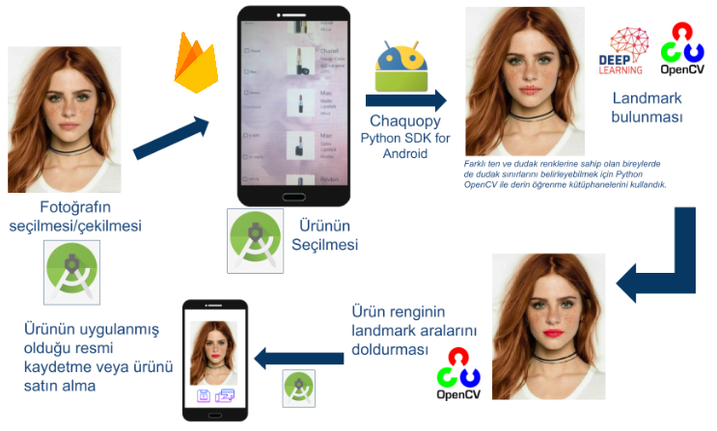

The most difficult point in realizing our mobile application was to run the lip painting code we wrote in python language on android studio platform. To do this, we used a technology called Chaquopy, which allows python code to run in android studio.

**GUI Pictures with Balsamiq Mockups**

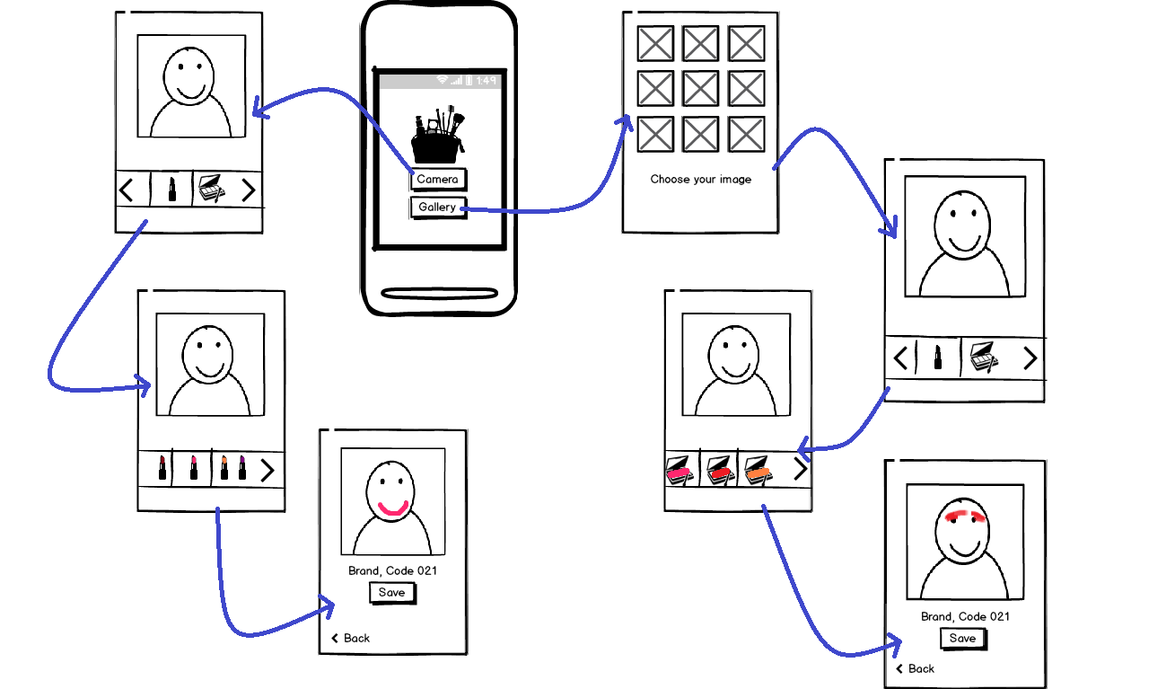

**Results**

In the first term of the school year given for our project, we investigated how to determine the face from the photograph, which programming language and development environments should be used, what libraries should be installed for face detection.

As a result of our research, we have added python language to the 68-landmark-dataset where the necessary libraries and face points are kept, especially OpenCV and Deep Learning libraries in the PyCharm development environment.

The 68-landmark-dataset is a datum with 1 to 68 numbered points for eye, eyebrow, lip, nose and chin. Using this dataset, we first determined the lip points. Then we found a code that paints lips using RGB color code. This code was a code that worked with specific points selected from the lip on a single image only. We have converted this code into a code that can change the color of the lip by compiling it to work on every photo using 68-landmark-dataset.

During this process, the most difficult part of the 68-landmark-dataset using the points we selected, the code we have found the interpolate function was to accept. At first, we applied the method of determining our own points in the photo without using the 68-landmark-dataset.

However, this method is a mobile application when we turn to give our users the difficulty we gave up. Then we solved this problem by selecting the points selected by the 68-landmark-dataset by matching the selected points in the sample code. For this, we have written a code that will enable us to see the points selected by the sample code on the photo.

In the second semester of the school year, we created a database base by adding two different products from each of the three different cosmetic brands. We used Firebase to create this database. We used the Android studio program to move our application to the mobile platform. We have listed the product data we have taken from the database and offered brand and price filtering options for the convenience of the user. Pycharm platform we wrote the lip painting code, android studio program, we ran the product trial part.

Filing Date : 11.06.2019

**Conclusion**

We believe that this application will provide a great comfort especially to people shopping on the internet. We offer a program that enables them to apply directly to their efforts to imagine how cosmetic products will stand. In addition, we live in a world where people of all ages and people from all walks have a smart phone.

We also believe that it is an application that will benefit cosmetics stores. We believe that these stores can eliminate the high cost they spend on providing testers to their customers by using deep makeup. We also offer customers the chance to test products in a hygienic way that tester products cannot offer.

**References**

[1] Face Detection & Facial Landmarks

<https://www.pyimagesearch.com/2017/04/10/detect-eyes-nose-lips-jaw-dlib-opencv-python/>

[2] Apply Makeup to Lip Example Code

<https://github.com/srivatsan-ramesh/Virtual-Makeup/tree/master/lips>

[3] Mouseclick for Select Face Points

<https://docs.opencv.org/3.0-beta/doc/py_tutorials/py_gui/py_mouse_handling/py_mouse_handling.html>

[4] Information about the point of the make-up for the Summary

<http://www.milliyet.com.tr/gecmisten-bugune-kozmetik-pembenar-yazardetay-saglik-2210083/>